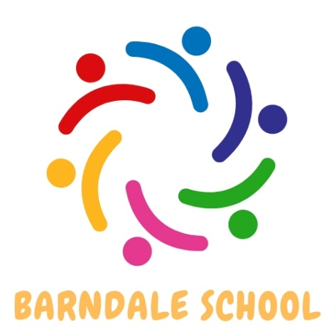

What I learn today, prepares me for tomorrow.

Barndale House School

Careers Overview

2024-2026

|  |  |  |
| --- | --- | --- |
| Barndale House Careers Overview |  | 2024-2026 (reviewed biennually) Next review date : September 2026 |
| School Context |  |  |
| Intent |  | At Barndale, our motto is what we learn today prepares me for tomorrow, we believe this links to preparing our young people for the world of work and the ability to live independently. It is through this vision that we aspire to ensure that every student is given every opportunity to experience the necessary skills in readiness for employment. Furthermore, we aim to provide a range of experiences which enable them to make informed choices about life beyond school; preparing them for the next stage of their education or training.  Learning about work skills starts as soon as students enter school in Class 1, where students learn key functional skills through our PSHE curriculum, Skills Builder and experience a career 6 times per year. These are built upon in Class 5 where students are taught through the Barclays Lifeskills programme, along a CEC unit. In Class 7 careers is taught through NCFE Employability accreditation, 1:1 careers advice interviews, visits to Careers Fairs, visits to local businesses and invitations sent for speakers to talk in school to us. |
| Implementation |  | Barndale’s careers plan outlines how the school Careers Programme is designed to equip young people with the confidence and skills needed to prepare them for their future, which may include further/higher education, supported living, apprenticeships, supported internships and employment. This takes place through bespoke support starting in our primary department through to our post 16 department and through our skills builder programme, life skills and PSHE curriculum. Our curriculum provides young people with opportunities to learn essential skills to prepare them for tomorrow. Our children will achieve personalised positive career outcomes such as identifying and choosing appropriate steps to take after post 16 and compulsory education as well as developing independent living skills, supported internships and work placements. |
| Impact |  | All young people in our school will be exposed to a range of careers during their time at Barndale. They will be made aware of their pathways, including apprenticeships or internships which can be adapted to the needs of the child. All children from Class 1 – Class 7 (EYFS-Y13) will receive an introduction to careers skills and information embedded within their curriculum - mainly through PSHE, Life Skills and real life experiences both in and out of school.  Pupils will transition from Barndale into clear pathways for adulthood such as supported internships, apprenticeships or relevant college courses. |
| Roles and  Responsibilities |  | This strategy is led and managed by Sarah Dickson  Telephone: 01665602541 Email: admin@barndalehouse.northumberland.sch.uk |

|  |  |  |  |  |  |  |
| --- | --- | --- | --- | --- | --- | --- |
| Curriculum Overview | | | | | | |
| All Year Round Whole School:Careers Day Focus (eg gardening, hospitality, retail, farming) across the whole school, one focus day per short term  Assemblies: NHS Choices, Buzz Learning, NCC Careers Service, Alnwick Gardens (EA) | | | | | | |
|  | |  | Autumn Term | Spring Term | Summer Term | Gatsby |
| Foxes | 1 |  | **Barclays Lifeskills**  Skills  <https://barclayslifeskills.com/help-others/lessons/skills-knock-out/>  Understanding Behaviours for Work  <https://barclayslifeskills.com/help-others/lessons/understanding-behaviours-for-work-lesson/>  **PSHE.org**  <https://primary-careers.careersandenterprise.co.uk/resources/linking-career-related-learning-pshe> | **Barclays Lifeskills**  Journey to your career  <https://barclayslifeskills.com/help-others/lessons/the-career-journey/>  Importance of Challenge  <https://barclayslifeskills.com/help-others/lessons/the-importance-of-challenge/> | **Barclays Lifeskills**  Let’s Talk Careers  <https://barclayslifeskills.com/help-others/lessons/let-s-talk-careers-quick-fire-activity/>  Setting Goals  <https://barclayslifeskills.com/help-others/lessons/setting-goals-lesson/> | 1 2 3 4 5 7 |
| 2 | Transferable Skills  <https://barclayslifeskills.com/help-others/lessons/transferable-skills-activity/>  Exploring different job sectors and roles  <https://barclayslifeskills.com/help-others/lessons/job-sectors-preparing-for-work-activity/> | Making the most of virtual work experience  <https://barclayslifeskills.com/help-others/lessons/making-the-most-of-your-virtual-work-experience/>  Creativity  <https://barclayslifeskills.com/help-others/lessons/creativity/> | Staying Positive  <https://barclayslifeskills.com/help-others/lessons/staying-positive-resilience/>  Communicating digitally in the world of work  <https://barclayslifeskills.com/help-others/lessons/communicating-digitally-in-the-world-of-work/> | 1 2 3 4 5 7 |
| Badgers | 1 | **PSHE.org**  <https://pshe-association.org.uk/resource/careers-education-year-9-10>  **Barclays Lifeskills**  Transferable Skills  <https://barclayslifeskills.com/help-others/lessons/transferable-skills-lesson-part-one-send-and-aln/> | **Barclays Lifeskills**  Building My Skills  <https://barclayslifeskills.com/help-others/lessons/building-my-skills-lesson-part-two-send-and-aln/>  Networking Skills  <https://barclayslifeskills.com/help-others/lessons/networking-skills-lesson/> | **Barclays Lifeskills**  CV Writing  <https://barclayslifeskills.com/help-others/lessons/cv-skills-lesson-one-writing-a-successful-cv/>  <https://barclayslifeskills.com/help-others/lessons/cv-skills-lesson-two-fine-tuning-your-cv-to-stand-out-to-employers/> | 1 2 3 4 5 7 |
| 2 | **PSHE.org**  <https://pshe-association.org.uk/resource/environment-agency-careers-for-change>  **Barclays Lifeskills**  Interview skills  <https://barclayslifeskills.com/help-others/lessons/interview-skills/> | **Barclays Lifeskills**  Understanding behaviours for Work  <https://barclayslifeskills.com/help-others/lessons/understanding-behaviours-for-work-lesson/>  The Journey to Your Career  <https://barclayslifeskills.com/help-others/lessons/the-career-journey/>  Enterprise Skills and Being Creative  <https://barclayslifeskills.com/help-others/lessons/enterprise-skills-and-being-creative-lesson-send-and-aln/>  Online Reputation  <https://barclayslifeskills.com/help-others/lessons/online-reputation-and-social-networking-lesson-send-and-aln/> | **CEC (10 lessons)**  <https://resources.careersandenterprise.co.uk/resources/ks3-english-careers-curriculum-resource> | 1 2 3 4 5 6 7 8 |
| Deer Class |  | 1:1 interviews with NCC Careers Advisor  Provide opportunities to visit prospective employers  PSD Unit Working Towards Goals  NCFE Employability | Alnwick Gardens Career Fair  Provide opportunities to visit prospective employers  NCFE Employability  Asdan Lifeskills Challenges | Provide opportunities to visit prospective employers  NCFE Employability  Asdan Lifeskills Challenges | 1 2 3 4 5 7 8 |

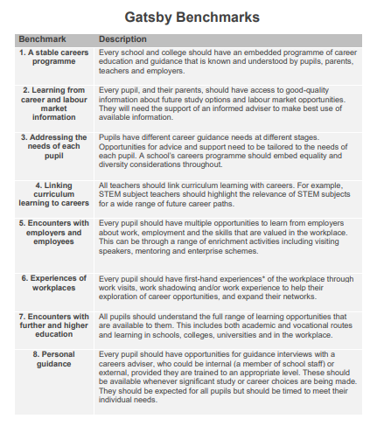

|  |  |
| --- | --- |
| Skills Builder Programme | The Skills Builder Careers Tutor Time Programme is being introduced as part of the wider curriculum. The aim is to ensure that our pupils have the opportunity to build a set of essential skills that colleges, universities and prospective employers require from a candidate |
| Asdan Lifeskills/PSD Courses | As a school, we work towards accreditations with ASDAN. For careers we will deliver the PSD Preparation for Work module and the Young People will choose a range of Lifeskills Challenges to receive certificate accreditations. |
| Work Experience | Work experience is a great way to build your skills and your CV and find out what you could enjoy doing in the world of work. Barndale will help arrange work experience opportunities. |
| Pathways Event | Barndale is committed to ensuring that students are given tailored advice and guidance on choosing their Key Stage 4 Pathway in a manner that extends thinking to future careers and ambitions. The Pathways event is designed to provide parents and students with the opportunity to prepare for this important milestone in their careers. |
| Career Interviews | Students are entitled to the opportunity to meet with a qualified and professional careers adviser for tailored and impartial information, advice and guidance on post-16/ post-18 options and next steps |
| Financial Literacy | Financial literacy is the ability to understand and effectively use various financial skills, including personal financial management, budgeting, and investing. |
| Careers Fair | An opportunity for encounters with a range of employers, further education providers, universities and more. Students are able to ask questions first hand, take advantage of free resources and access to useful information, establish professional relationships, and also discuss potential future opportunities. |
| Mock Interviews | At Barndale House we understand the importance of preparing our students for the demands of working life. Many students are invited to interviews when applying to post -16/18 options and may be invited to a job interview in the future. Therefore, we invite employers and business volunteers into the school to hold one-to-one or group interviews which resembles a real interview |
| Offsite Visit linked to developing employability skills | A variety of exciting trips are planned for students to get them to reflect on their future. Therefore, they will visit a university and/or an organisation for an introduction to higher education and/or employment. |