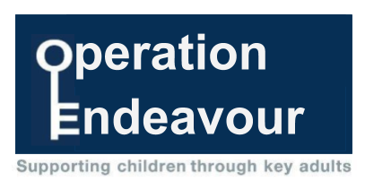

September 2022

Dear Parent/Carer
I am writing to inform you about Operation Endeavour. This is an innovative project in which schools and colleges in Northumberland are participating, and which is run in partnership with Northumberland County Council and Northumbria Police.
Operation Endeavour aims to support children and young people who go missing from home. Children who go missing from home are at risk of significant harm and they may be vulnerable to sexual exploitation, violent crime, gang exploitation, or to drug and alcohol misuse.
As a result, following any report of a child going missing to the Police, the Police will make contact with Children’s Social Care who will then communicate relevant and necessary information to nominated school staff.
Each school has members of staff (key adults) who have been fully trained in liaising with the Police and Children’s Social Care when required and will ensure that the necessary support is made available to the child or young person following their return.
I believe that this project demonstrates our school’s commitment to working in partnership to safeguard and protect children, and to providing the best possible care and support for our pupils.
In the meantime, if you would like to speak to someone further about the project or require further information please contact our key adults in school who are Mark Phillips (Headteacher), Sarah Dickson (Deputy Headteacher) and Lisa Muir (Family Support Partner).
Kind regards,
Mark Phillips
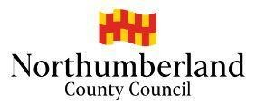
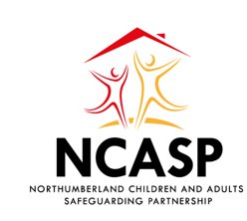
Headteacher

